HabotConnect Hiring Project
Candidate Name: Amruta Suryavanshi
Email: amrutasuryavanshi212@gmail.com
Phone: 9503700849

Table of Contents
- Project Overview
- Project Objectives
- Technology Stack
- Architecture
- Project Folder Structure
- Task 1
- Task 2
- Task 3
- Security
- Testing
- Challenges
- Future Improvements
- Conclusion
- References

Project Overview
This project simulates a real-world production scenario where security vulnerabilities and data validation issues must be resolved using DevOps best practices. It demonstrates secure Google Cloud infrastructure provisioning with Terraform, automated CI/CD build gates, and robust data validation using Django REST Framework to ensure secure, reliable, and compliant application deployments.

Project Objectives
- Provision secure GCP resources using Terraform.
- Implement IAM, RBAC, and Row-Level Security (RLS).
- Build a fail-closed CI/CD pipeline with automated linting and security scanning.
- Detect and block hardcoded secrets in code.
- Validate student onboarding data using Django REST Framework serializers.
- Ensure data integrity and schema consistency for analytics.
- Demonstrate DevOps automation, cloud security, and Infrastructure as Code (IaC) best practices.

Technologies Used

Cloud Platform
- Google Cloud Platform (GCP)

Infrastructure as Code (IaC)
- Terraform

Cloud Services
- Google Cloud Storage (GCS)
- BigQuery
- Identity and Access Management (IAM)

Backend
- Python 3
- Django
- Django REST Framework (DRF)

CI/CD
- GitHub Actions

Code Quality & Security
- Black (Python Code Formatter)
- Flake8 (Python Linter)
- Bandit (Security Scanner)
- Detect-Secrets (Secret Detection)
- Terraform fmt
- Terraform validate
- Terraform plan

Version Control
- Git
- GitHub

Development Tools
- Visual Studio Code
- Google Cloud CLI (gcloud)
- Terraform CLI

Architecture
The project follows a secure DevOps workflow that automates infrastructure provisioning, code quality checks, security validation, and data validation before deployment.

Architecture Flow
Developer
↓
GitHub Repository
↓
GitHub Actions (CI Pipeline)
↓
Source Code Checkout
↓
Install Dependencies
↓
Code Formatting (Black)
↓
Python Linting (Flake8)
↓
Security Scan (Bandit)
↓
Secret Detection (Detect-Secrets)
↓
Terraform Format Check
↓
Terraform Validation
↓
Terraform Plan
↓
Pipeline Status
• If any validation fails → Build is blocked (Fail-Closed)
• If all validations pass → Infrastructure deployment is approved
↓
Terraform
↓
Google Cloud Platform
• Google Cloud Storage (D0 Raw Landing Bucket)
• BigQuery Dataset (D1 Staged/Enforced)
• IAM Role Assignments (Least Privilege)
↓
Django REST Framework API
↓
Serializer Validation (DCYN Logic)
↓
Validated Data
↓
BigQuery Analytics

Folder Structure
habot-devops-project/
├── terraform/
│ ├── provider.tf
│ ├── variables.tf
│ ├── terraform.tfvars
│ ├── main.tf
│ ├── outputs.tf
│
├── django/
│ ├── models.py
│ ├── serializers.py
│ ├── views.py
│ └── urls.py
│
├── .github/
│ └── workflows/
│ └── ci.yml
│
├── docs/
├── presentation/

Task 1 – Terraform Infrastructure Provisioning

1. Infrastructure as Code (IaC)
- Infrastructure is created using code instead of manual configuration.
- Terraform automates cloud resource provisioning.
- Ensures consistent and repeatable deployments.
- Reduces human errors.
- Infrastructure can be version controlled using Git.
Code: provider.tf, main.tf, variables.tf
Screenshot :
- Terraform project structure
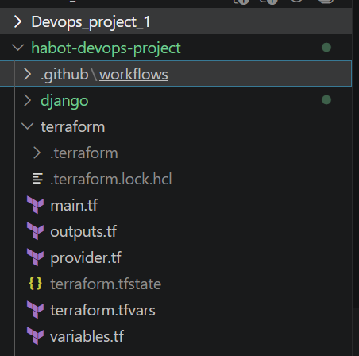
- terraform apply output
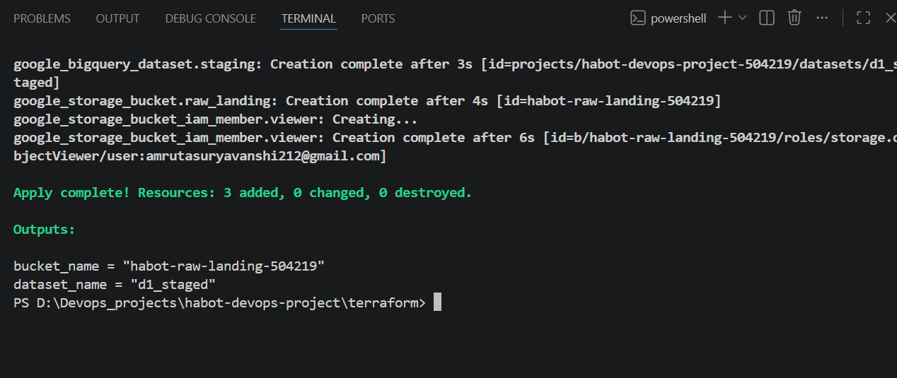

2. Terraform Provider
- Connects Terraform to Google Cloud Platform.
- Authenticates using Google Cloud credentials.
- Specifies the target project and region.
- Allows Terraform to create and manage GCP resources.
Code: provider.tf

provider "google" {
project = var.project_id
region = var.region
}

Screenshot :
- Provider configuration
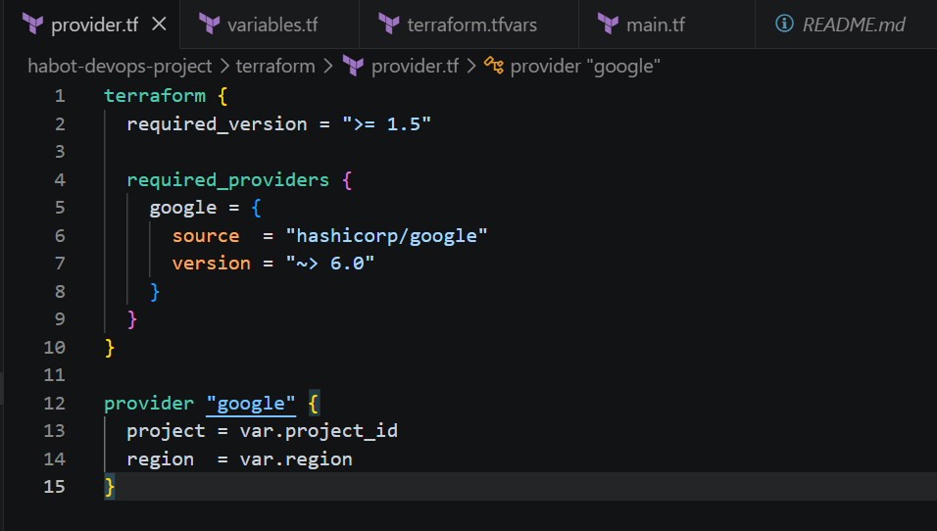
- GCP project details
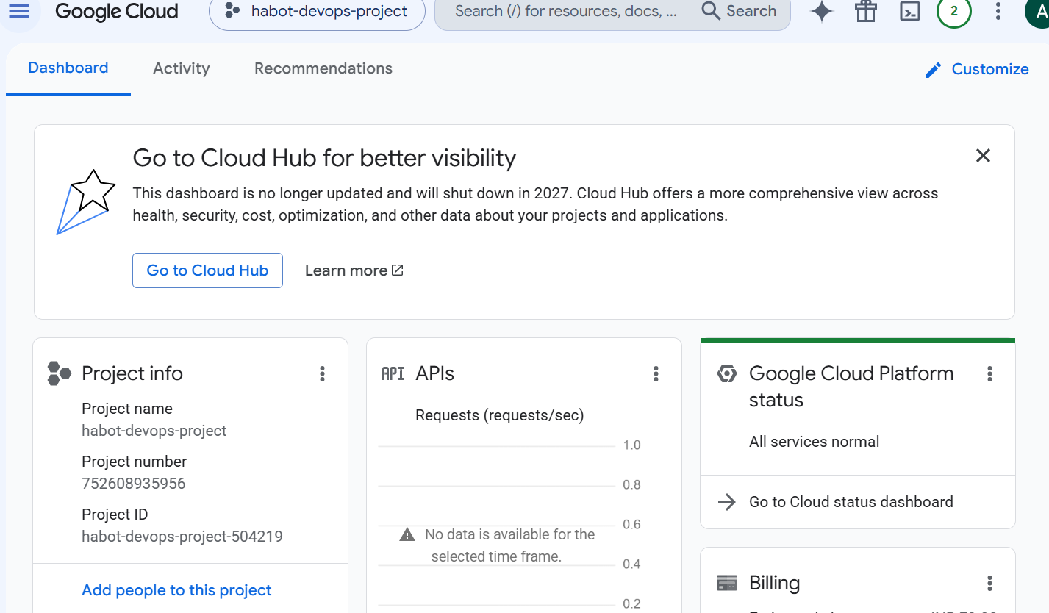

3. Variables
- Store reusable configuration values.
- Avoid hardcoding project-specific information.
- Improve code readability and maintainability.
- Easily deploy the same code to different environments.
Examples:
- Project ID
- Region
- Bucket Name
- Dataset Name
Code: variables.tf, terraform.tfvars
variable "project_id" {
description = "Google Cloud Project ID"
type = string
}

variable "region" {
description = "Deployment Region"
type = string
default = "asia-south1"
}

variable "bucket_name" {
description = "Raw Landing Bucket"
type = string
}
Screenshot:
- Variables file
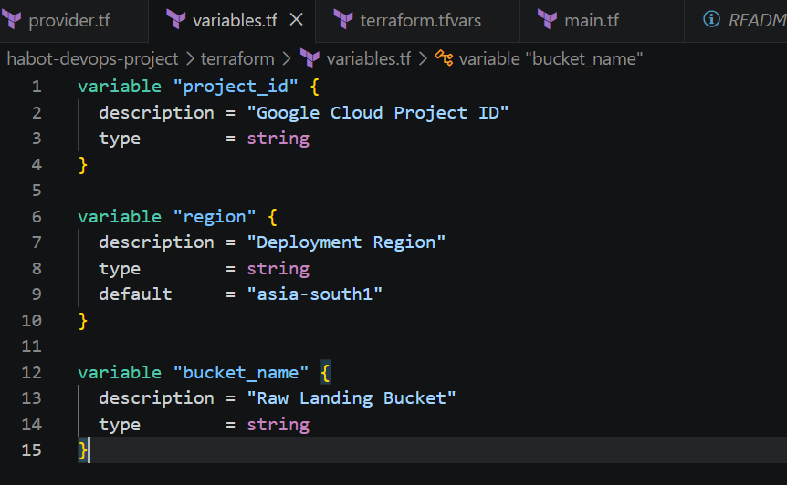

4. Google Cloud Storage Bucket
- Created as the Raw Landing (D0) storage.
- Stores incoming student onboarding data.
- Configured with secure settings.
- Supports future data processing.
Security Features:
- Uniform Bucket-Level Access
- Public Access Prevention
- Versioning
Code: main.tf
resource "google_storage_bucket" "raw_landing" {
name = var.bucket_name
location = "ASIA"

uniform_bucket_level_access = true

versioning {
enabled = true
}

public_access_prevention = "enforced"

force_destroy = false
}

Screenshot:
- Bucket overview
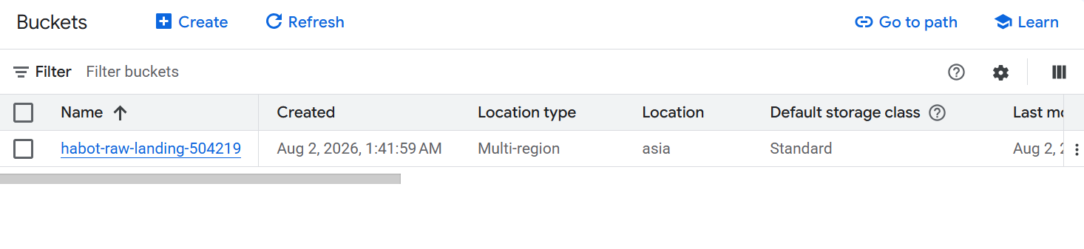
- Bucket configuration
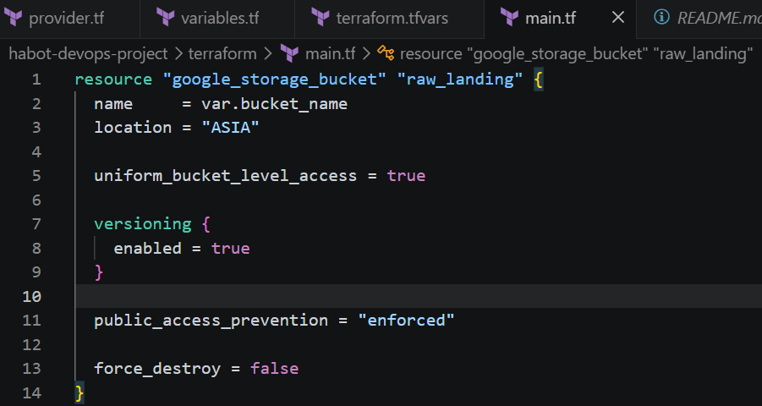

5. BigQuery Dataset
- Created as the Staged (D1) data layer.
- Stores validated and structured data.
- Used for reporting and analytics.
- Integrates with future data pipelines.
Code: main.tf
resource "google_bigquery_dataset" "staging" {
dataset_id = "d1_staged"
location = var.region

delete_contents_on_destroy = false
}
Screenshot:
- BigQuery dataset
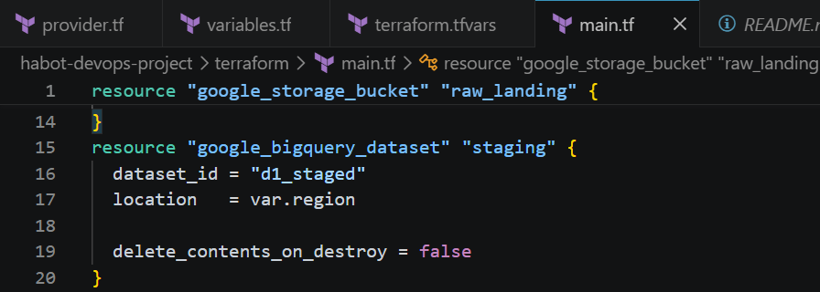
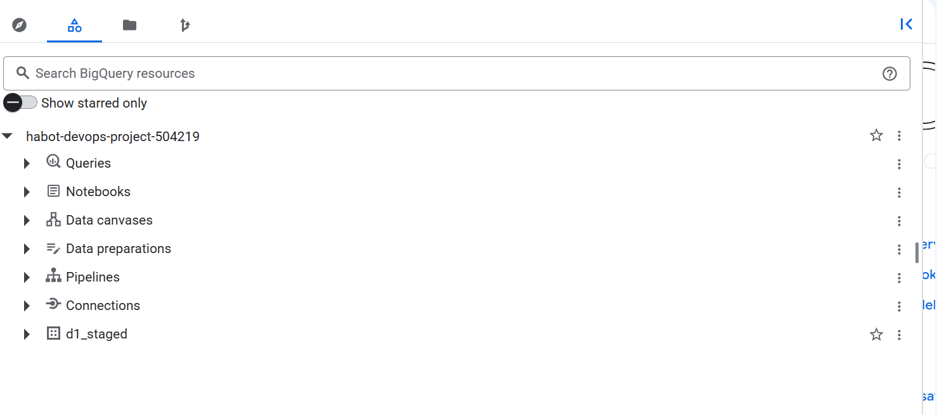

6. BigQuery Row-Level Security (RLS)

Purpose
- Restricts access to specific rows in the BigQuery table.
- Protects sensitive student information.
- Ensures users only view authorized records.
- Supports secure analytics and reporting.

Implementation
- Applied on the student_data table.
- Uses a BigQuery Row Access Policy.
- Filters rows based on the school column.
- Configured using SQL DDL after Terraform deployment.

SQL
CREATE ROW ACCESS POLICY school_policy
ON `habot-devops-project-504219.d1_staged.student_data`
GRANT TO ("user:amrutasuryavanshi212@gmail.com")
FILTER USING (school = 'ABC School');

Benefits
- Protects confidential student data.
- Implements the Principle of Least Privilege.
- Prevents unauthorized access to table rows.
- Improves data privacy and security.

Screenshot
- Row Access Policy page
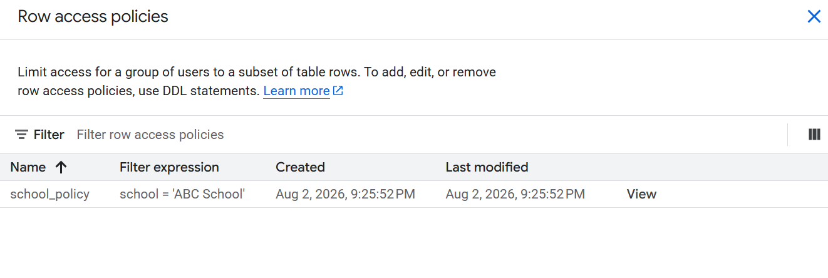
- BigQuery table with RLS configured
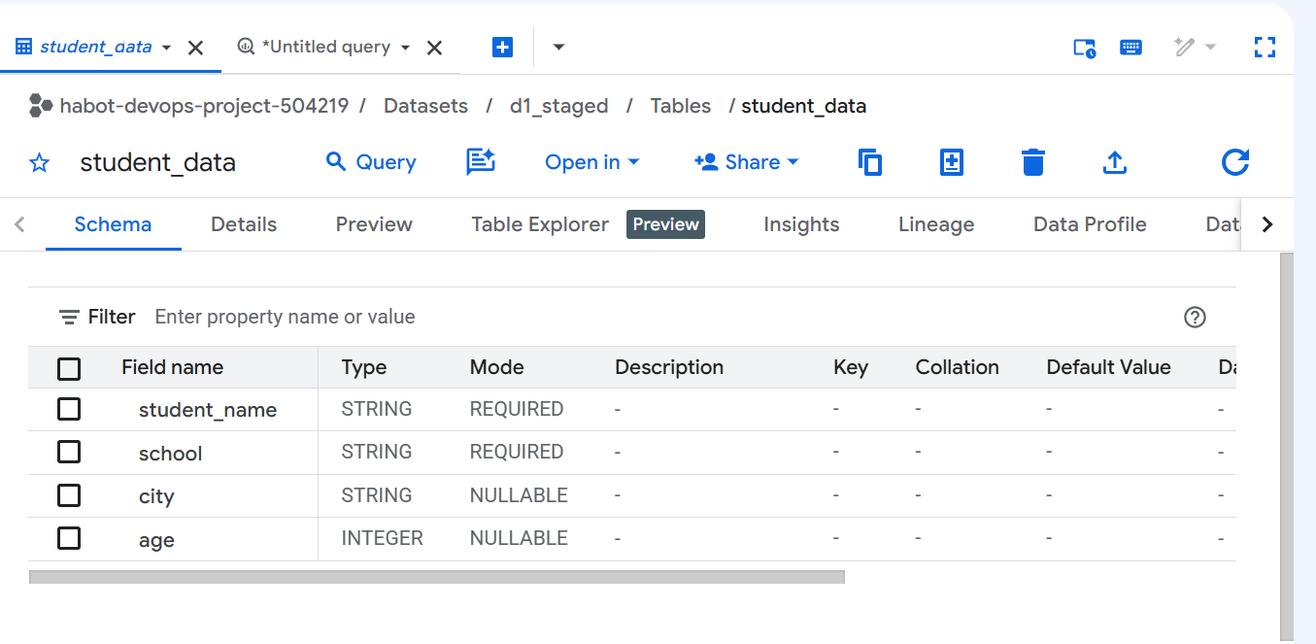
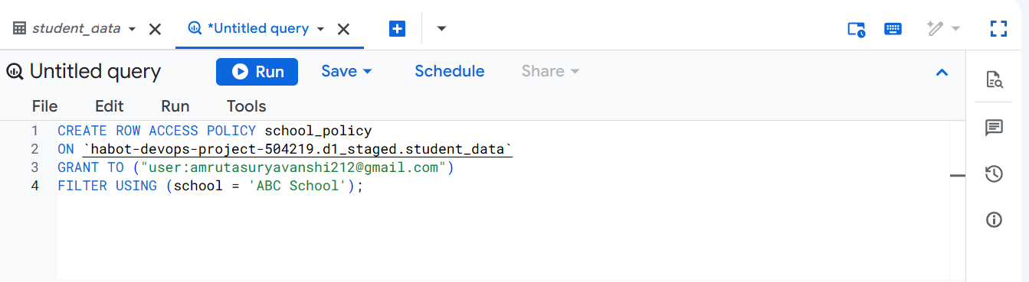

7. Identity and Access Management (IAM)
- Controls access to cloud resources.
- Assigns roles to users and service accounts.
- Prevents unauthorized access.
- Implements Role-Based Access Control (RBAC).
Code: main.tf
resource "google_storage_bucket_iam_member" "viewer" {
bucket = google_storage_bucket.raw_landing.name
role = "roles/storage.objectViewer"
member = "user:amrutasuryavanshi212@gmail.com"
}
Screenshot:
- IAM permissions
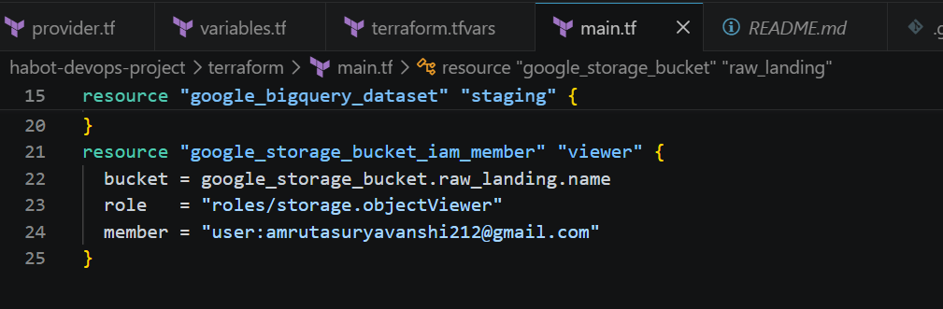
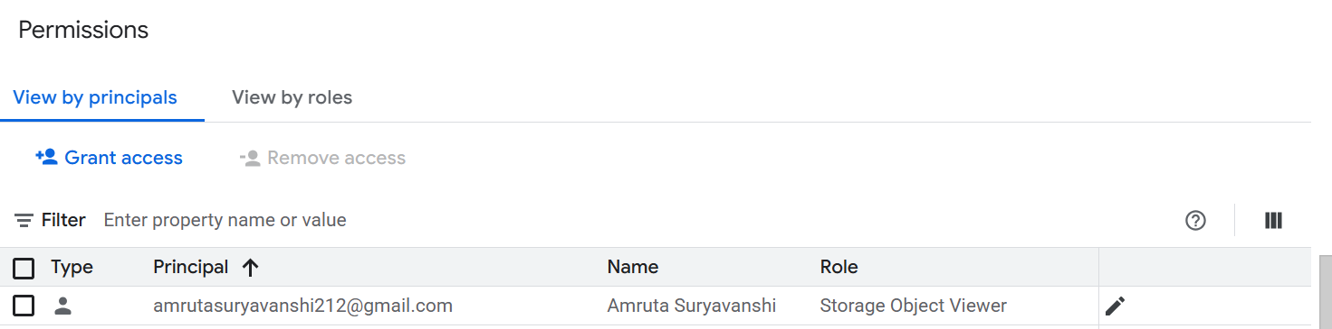

8. Principle of Least Privilege
- Grants only the minimum permissions required.
- Prevents unnecessary administrative access.
- Improves cloud security.
- Reduces the risk of accidental changes.
Screenshot:
- IAM role assignment
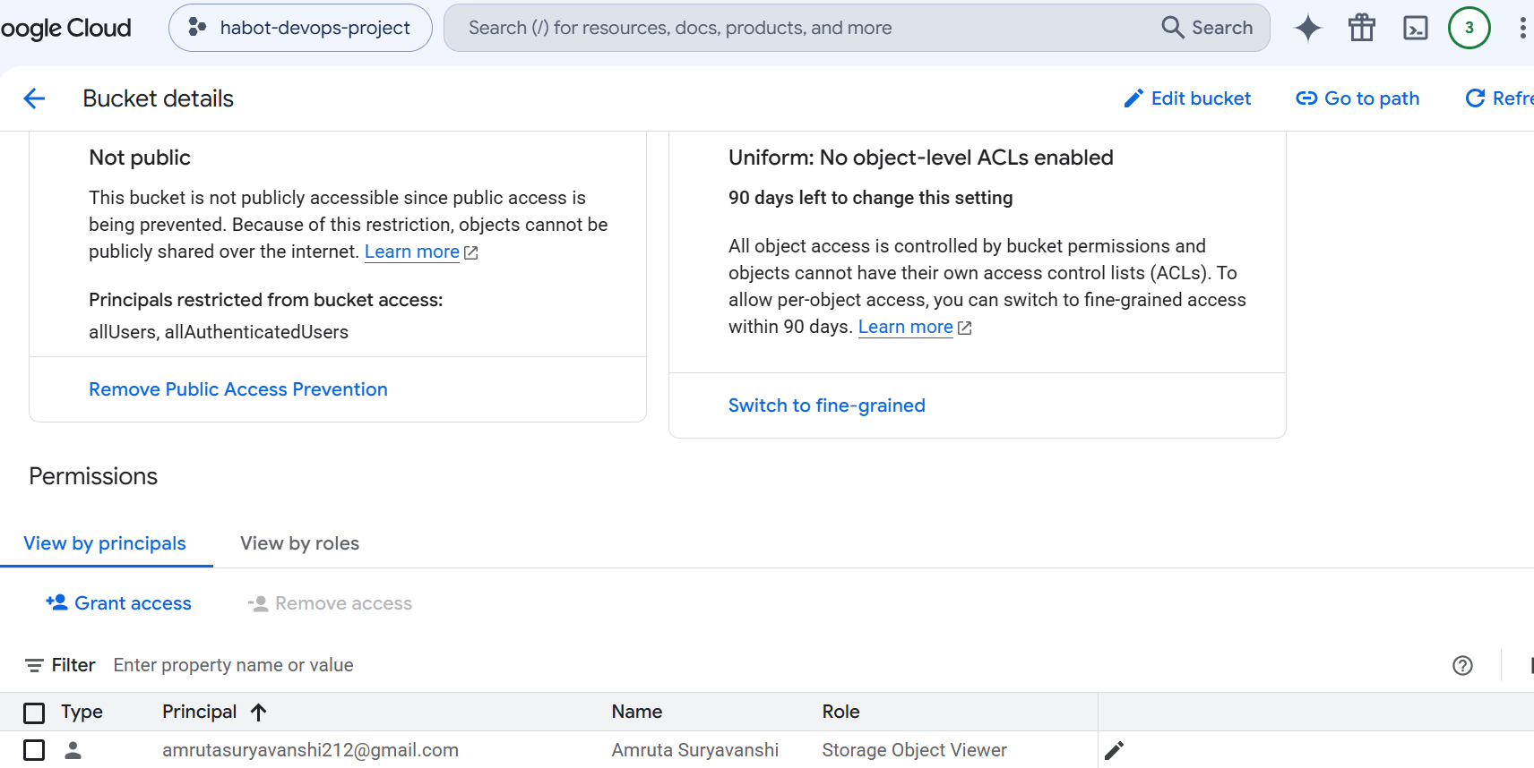

9. Public Access Prevention
- Blocks public access to the Cloud Storage bucket.
- Ensures only authorized users can access data.
- Protects sensitive student information.
- Enabled at the bucket level.
Verification:
Cloud Storage → Bucket → Protection → Public Access Prevention = Enforced
Screenshot:
- Public Access Prevention enabled
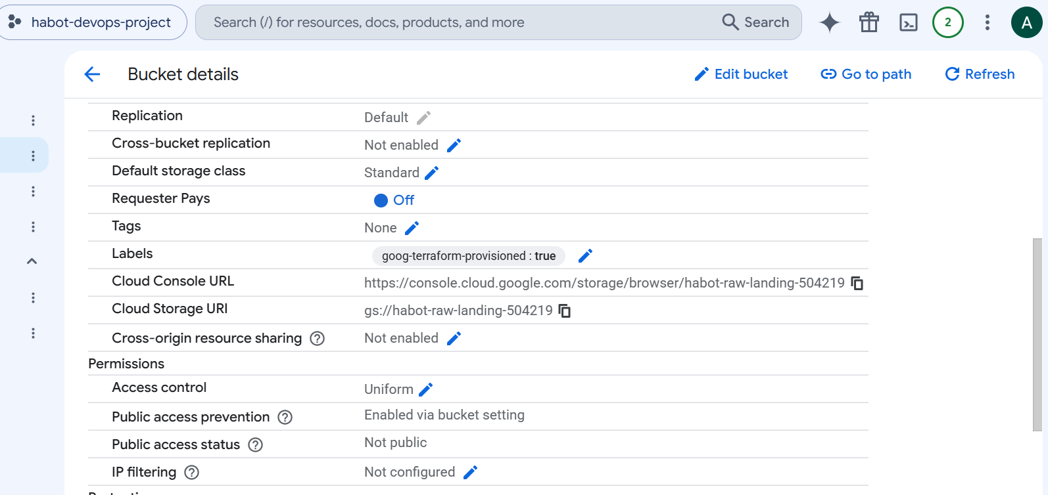

10. Versioning
- Keeps previous versions of uploaded files.
- Protects against accidental deletion or overwriting.
- Allows recovery of older file versions.
- Improves data reliability.
Verification:
Cloud Storage → Bucket → Protection → Versioning = Enabled
Screenshot:
- Versioning enabled
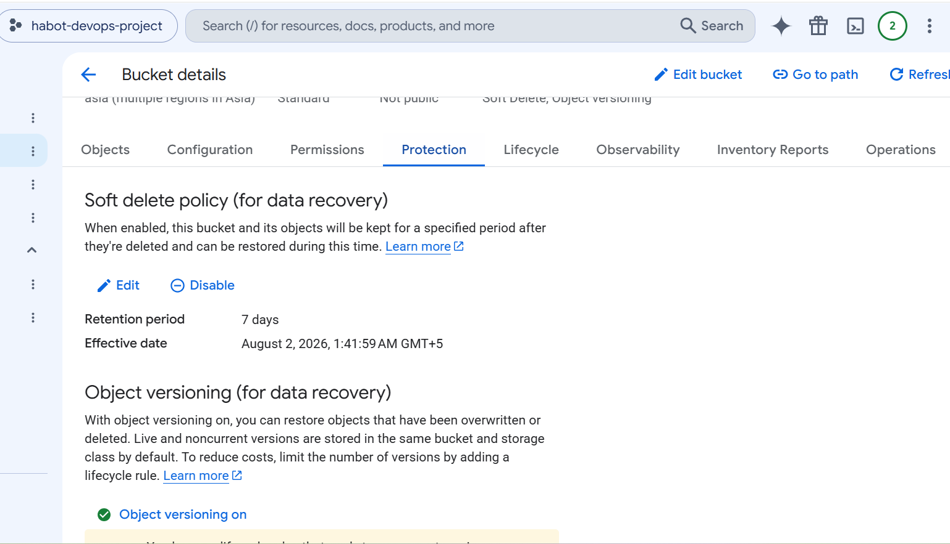

11. Terraform Deployment Steps
- Write Terraform configuration files.
- Run terraform init.
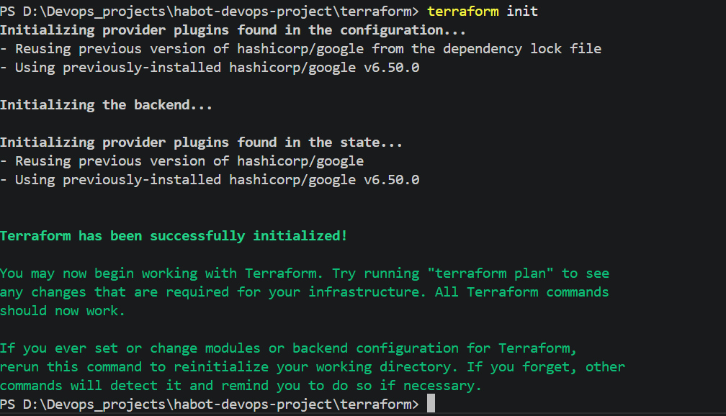
- Run terraform fmt.
- Run terraform validate.
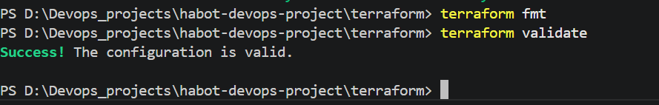
- Run terraform plan.
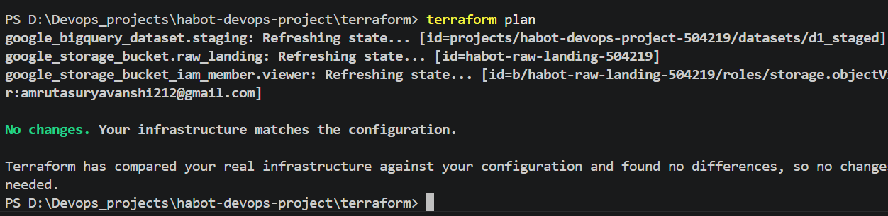
- Run terraform apply.

- Verify resources in Google Cloud Console.


Task 2 – Poka-Yoke Automated CI/CD Build Gate

Task 2 Overview
The objective of Task 2 is to create an automated CI/CD pipeline using GitHub Actions. The pipeline automatically checks code quality, security, and Terraform configuration before allowing deployment. If any validation fails, the pipeline immediately stops (Fail-Closed) to prevent insecure or incorrect code from being deployed.

1. Why CI/CD?
- Automates code validation after every push.
- Detects errors early in the development process.
- Maintains code quality and consistency.
- Reduces manual testing effort.
- Prevents deployment of faulty code.
Purpose: Improve software quality through automation.

2. Why Fail-Closed?
- Stops the pipeline immediately when an error is detected.
- Prevents insecure or invalid code from being deployed.
- Ensures only validated code reaches the next stage.
- Increases application security and reliability.
Purpose: Block deployment if any validation fails.

3. Poka-Yoke (Mistake-Proofing)
- Automates checks to eliminate human errors.
- Prevents accidental commits of bad or insecure code.
- Enforces coding standards automatically.
- Ensures every commit follows project rules.
Purpose: Prevent mistakes before deployment.

4. CI/CD Workflow
Developer Push
│
▼
GitHub Actions
│
▼
Checkout Repository
│
▼
Install Python
│
▼
Black
│
▼
Flake8
│
▼
Bandit
│
▼
Secret Scan
│
▼
Terraform Validate
│
▼
PASS
│
▼
Ready for Deployment

5.Testing Fail-Closed Pipeline

Test 1 – Black
- Remove proper spacing or formatting.
- Expected: Black fails and pipeline stops.
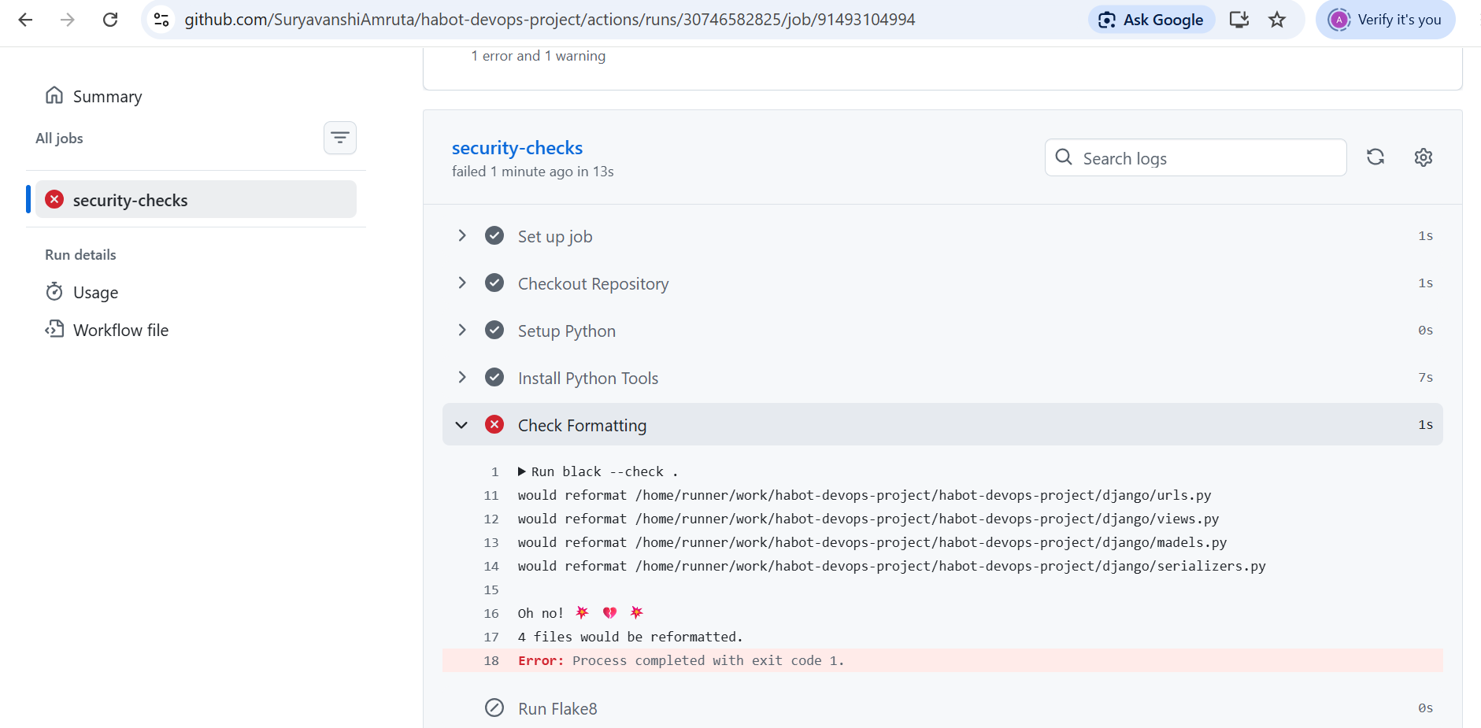

Test 2 – Flake8
- Add an unused import.
- Expected: Flake8 reports an error.
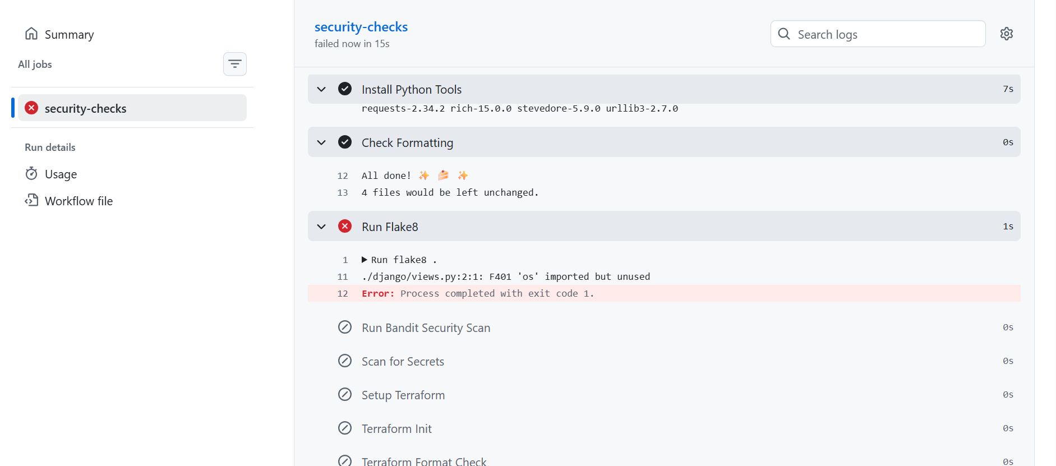

Test 3 – Bandit
- Add insecure code (e.g., eval()).
- Expected: Bandit detects a security issue.
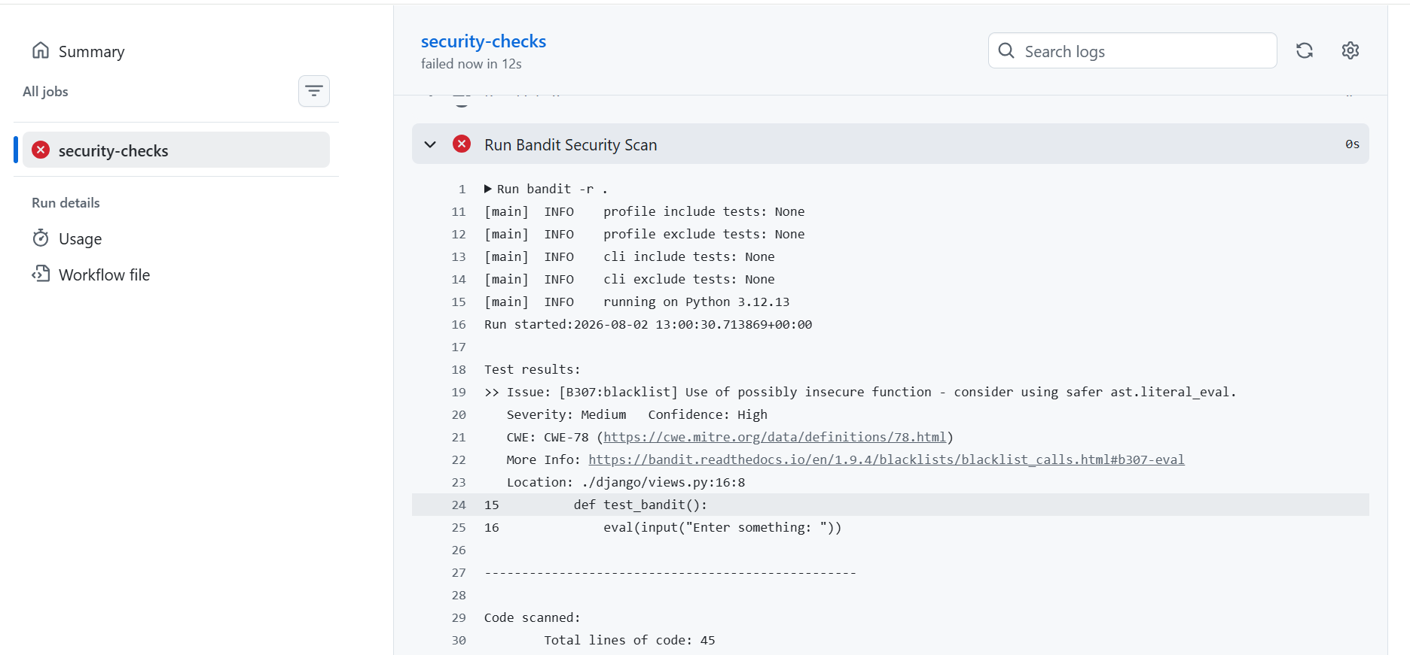

Test 4 – Secret Scan
- Add a fake API key in a Python file.
- Expected: Secret scan detects the secret and fails.
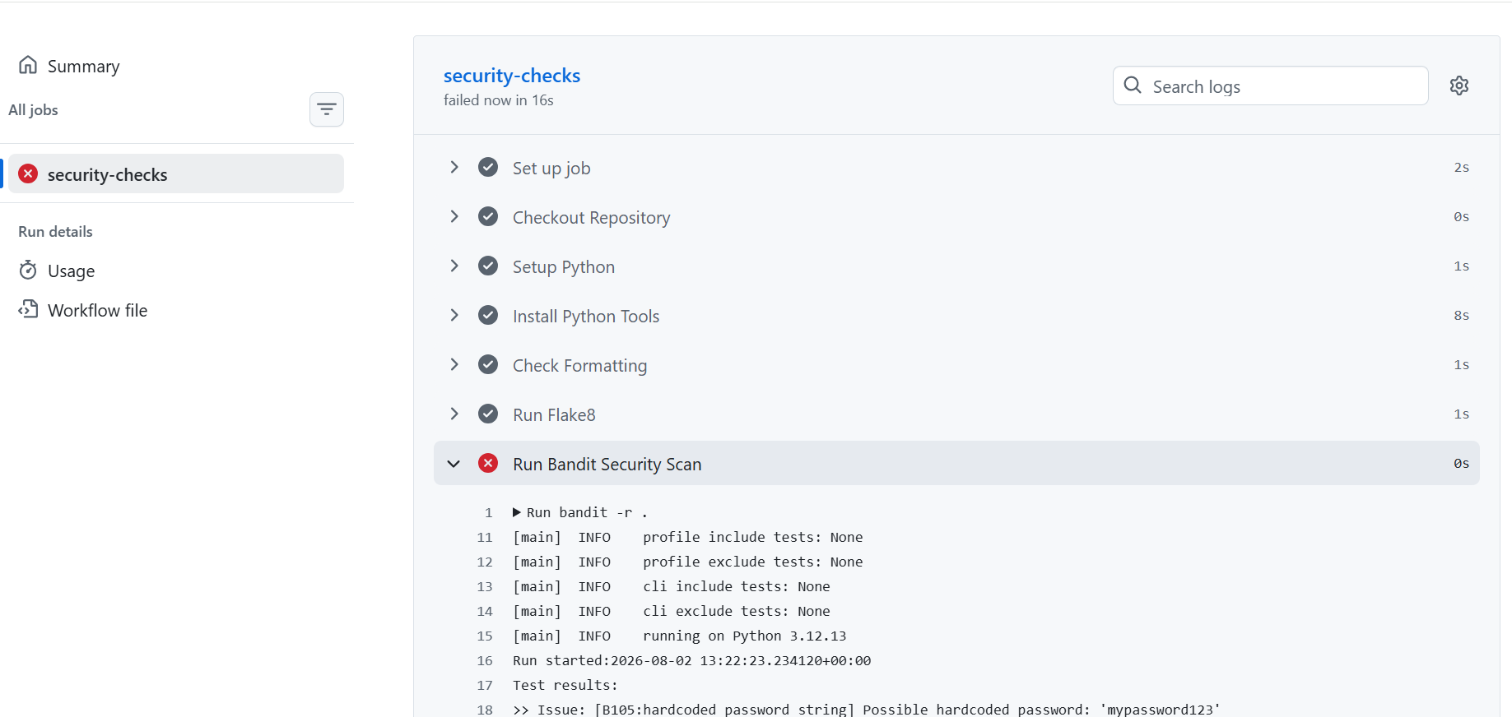

Test 5 – Terraform Validate
- Remove a closing brace (}) from a .tf file.
- Expected: Terraform validation fails.
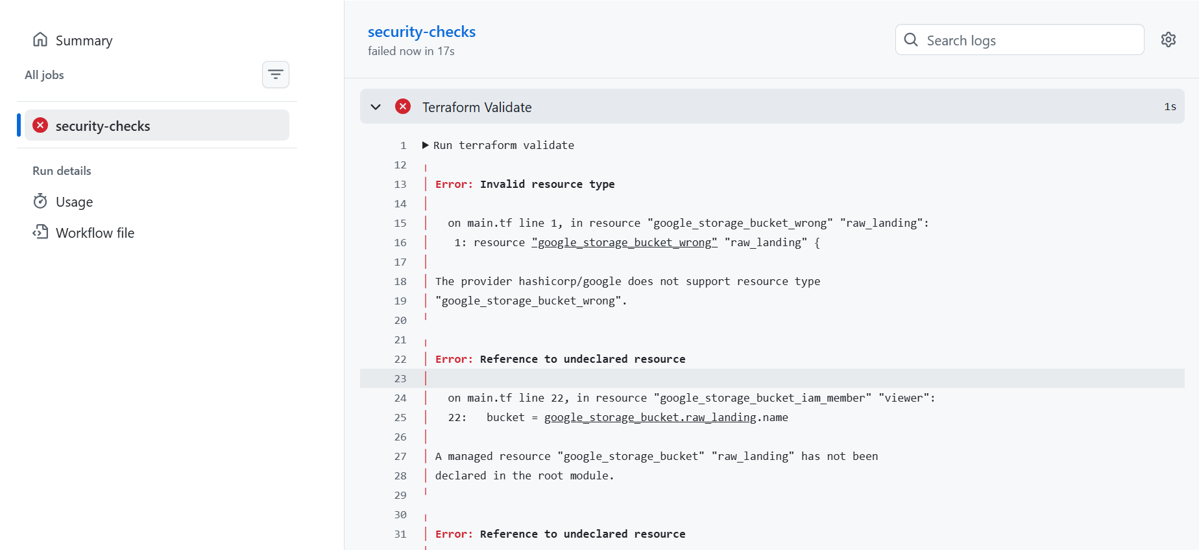
Successful pipeline
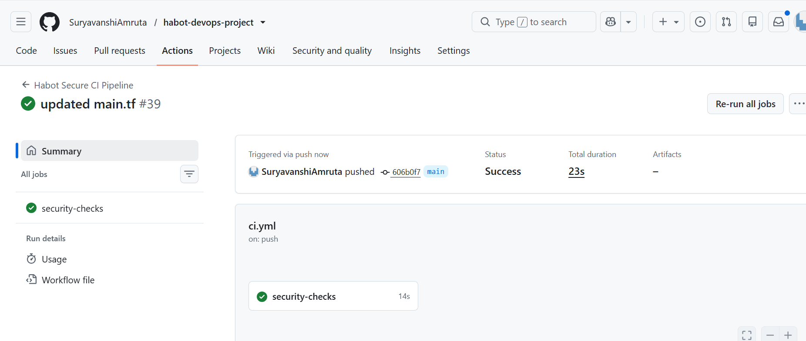

Task 3 – Schema Mapping and DCYN Validation

1. Student Onboarding JSON
- Student details are submitted from the React application in JSON format.
- Contains student information such as name, age, email, phone, and learning difficulty.
- Sent to the Django REST API for validation.
Purpose: Standardize data exchange between frontend and backend.
Sample JSON
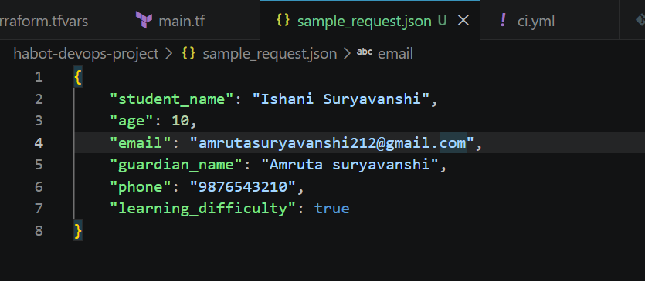

2. Why Schema Validation Matters
- Ensures all required fields are provided.
- Prevents invalid or incomplete data.
- Maintains data consistency.
- Protects database and analytics from incorrect records.
- Returns clear validation errors.
Purpose: Improve data quality and reliability.

3. Django REST Framework (DRF) Serializer
- Receives incoming JSON data.
- Validates each field.
- Rejects invalid requests.
- Saves only validated data to the database.
Purpose: Validate data before storage.
serializers.py
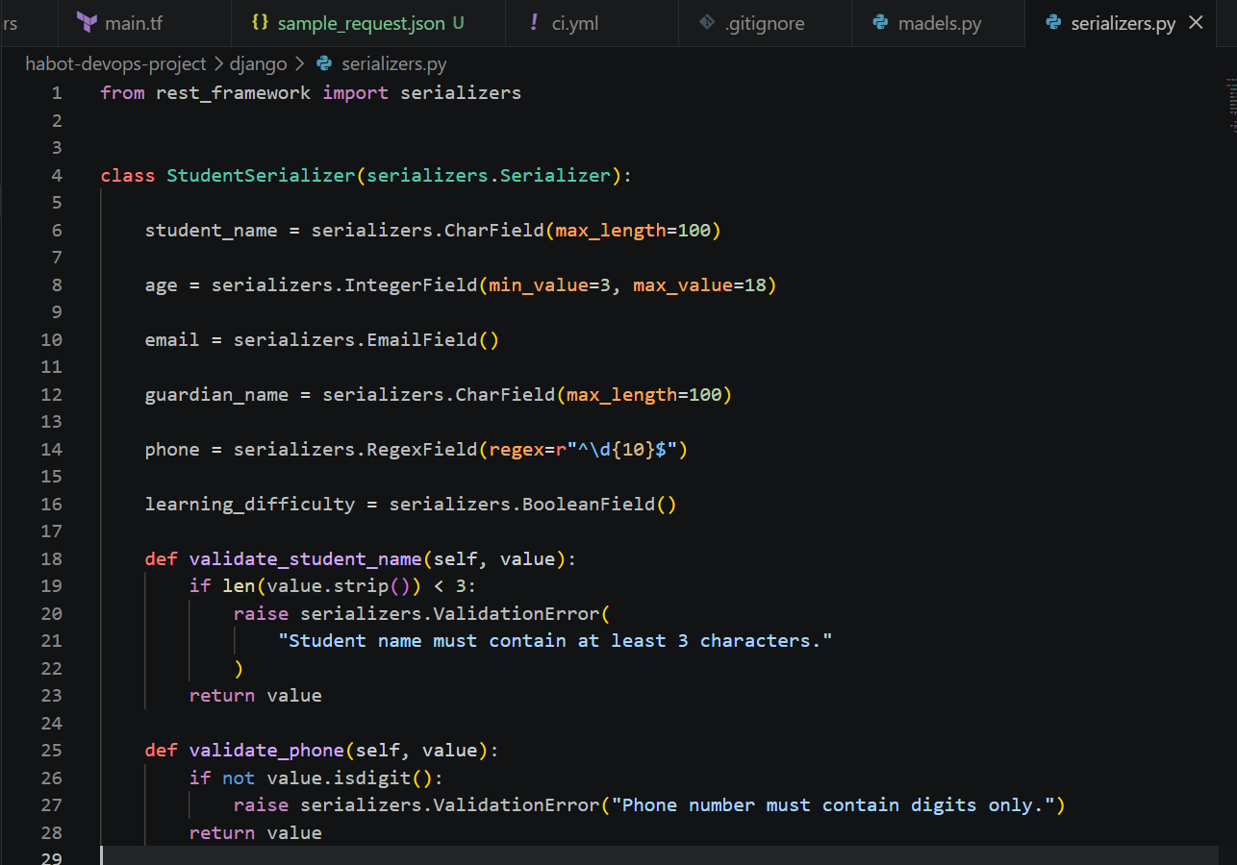

4. Field Validation
- Checks required fields.
- Verifies data type and format.
- Applies character and value limits.
- Ensures valid email and phone number.
- Validates Boolean fields.
Purpose: Ensure only valid data is accepted.
Field | Validation Rule | Accept | Reject
Student Name | Required, max 100 chars | ✔ | ✘
Age | 3–18 | ✔ | ✘
Email | Valid email | ✔ | ✘
Phone | 10 digits | ✔ | ✘
Learning Difficulty | Boolean | ✔ | ✘

5. DCYN (Yes/No) Logic
- Every field is checked against predefined rules.
- Validation has only two outcomes:
  - Yes → Accept
  - No → Reject
- Eliminates manual judgment.
Purpose: Apply consistent, rule-based validation.
Validation Check | Yes | No
Student Name provided | ✔ | ✘
Age between 3–18 | ✔ | ✘
Valid Email | ✔ | ✘
Phone has 10 digits | ✔ | ✘
Boolean value | ✔ | ✘

6. models.py
- Defines the Student database model.
- Specifies fields and data types.
- Creates the database table.
models.py
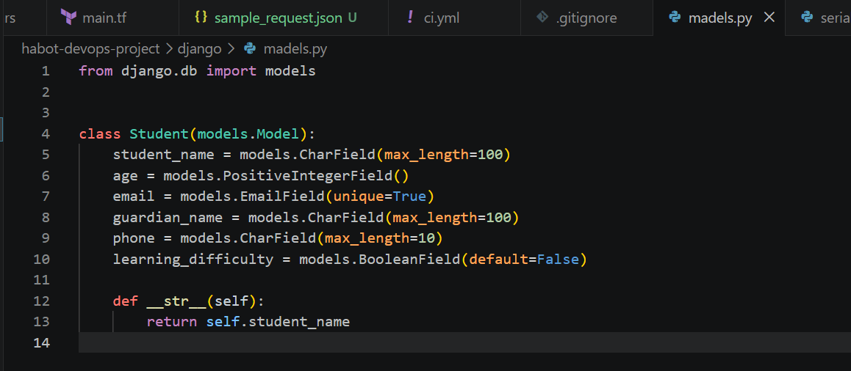

7. serializers.py
- Validates incoming JSON.
- Applies field validation rules.
- Returns validation errors.
- Saves validated records.
serializers.py
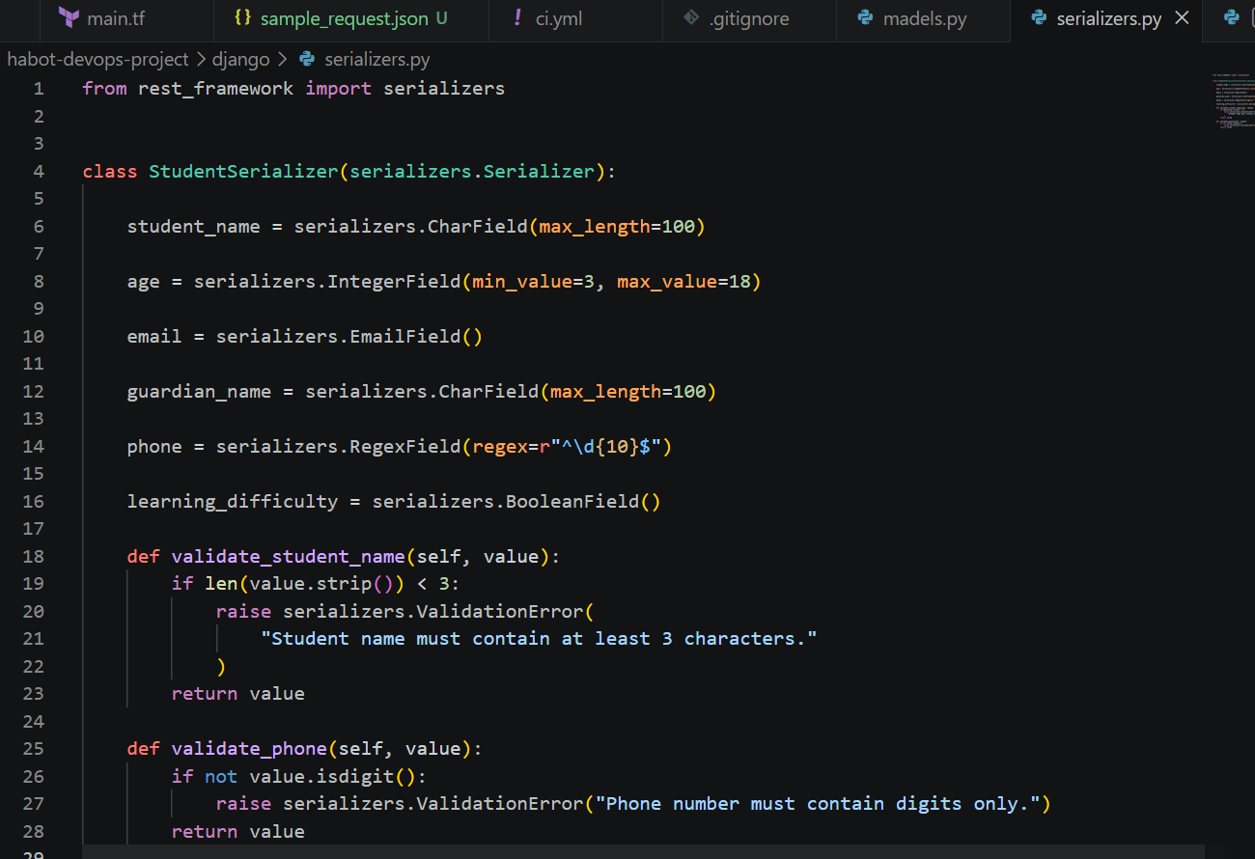

8. views.py
- Handles API requests.
- Sends data to the serializer.
- Returns success or error responses.
views.py
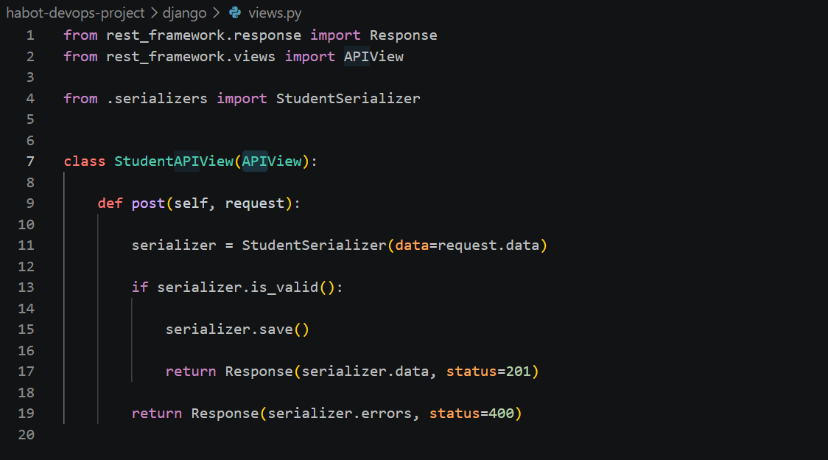

9. urls.py
- Defines API endpoints.
- Maps URLs to Django views.
urls.py
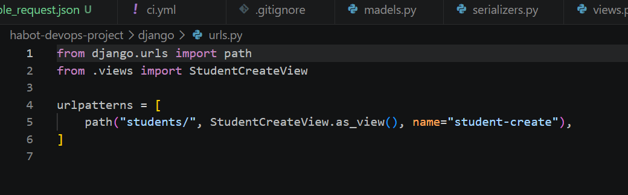

10. Sample JSON
- Contains valid student onboarding data.
- Used to test the API.
Sample JSON Request
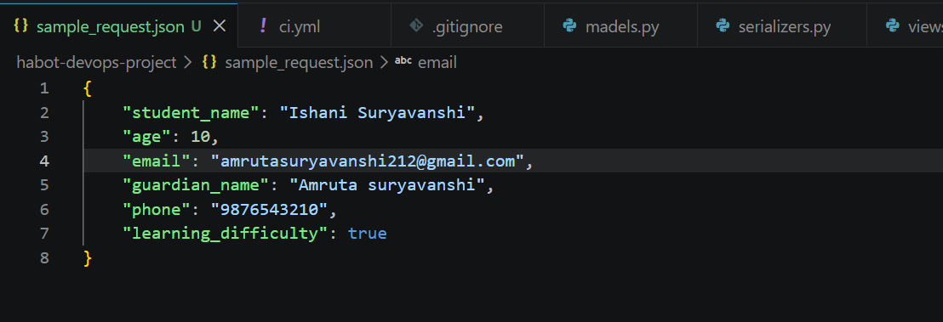

Future Improvements
- Implement remote Terraform state management.
- Integrate Google Secret Manager for secure credential storage.
- Add monitoring and alerting using Google Cloud Monitoring.
- Extend the CI/CD pipeline with additional security and automated tests.
- Support multi-environment deployments (Development, Staging, Production).

Conclusion
This project demonstrates secure cloud infrastructure provisioning using Terraform, Google Cloud Platform, GitHub Actions, and Django REST Framework. It implements Infrastructure as Code (IaC), secure IAM practices, Row-Level Security (RLS), and an automated Fail-Closed CI/CD pipeline. The solution meets the project requirements by providing secure deployment, automated validation, and reliable data processing for the HabotConnect platform.

